Project: HR Analytics — Employee Attrition & Workforce Planning
Process Flow Diagram
Project: HR Analytics — Employee Attrition & Workforce Planning
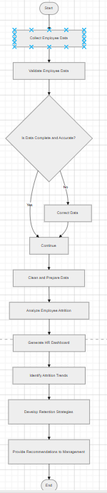
The process flow diagram illustrates the steps involved in analyzing employee attrition within the organization. The process begins with collecting employee data, followed by validation and cleaning to ensure data accuracy. Once prepared, the data is analyzed to identify attrition patterns and trends. The insights generated are used to develop retention strategies and provide actionable recommendations to management for improving workforce planning and reducing employee turnover.
Activity Diagram
Project: HR Analytics — Employee Attrition & Workforce Planning
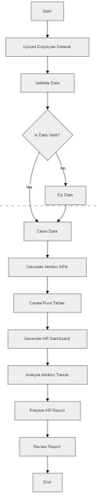
The activity diagram illustrates the workflow involved in employee attrition analysis. The process begins with uploading the employee dataset, followed by data validation and cleaning to ensure accuracy. The system calculates key attrition metrics and generates dashboards for visualization. The Business Analyst analyzes trends and prepares reports, which are reviewed by management to support retention strategies and workforce planning decisions.

Use Case Diagram
Project: HR Analytics — Employee Attrition & Workforce Planning
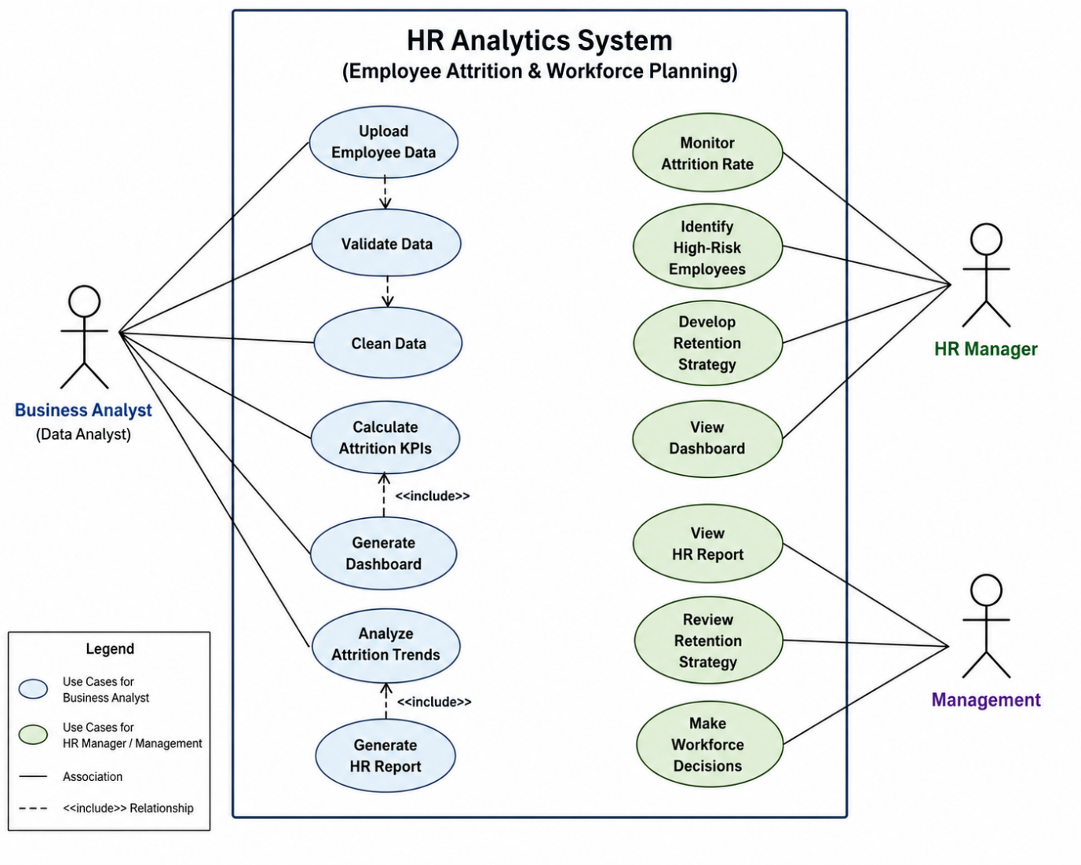
The use case diagram illustrates the interaction between users and the HR Analytics System. The Business Analyst is responsible for uploading, cleaning, and analyzing employee data to generate dashboards and reports. The HR Manager monitors attrition trends and identifies high-risk employees to develop retention strategies. Management reviews reports and makes workforce planning decisions based on the insights provided by the system.

Business Requirements Document (BRD)
Project Title: HR Analytics — Employee Attrition & Workforce Planning
Prepared By: Business Analyst
Date: 2025
1. Executive Summary
The purpose of this project is to analyze employee attrition patterns using HR data and provide insights to support workforce planning and retention strategies. High employee turnover can lead to increased recruitment costs, reduced productivity, and loss of organizational knowledge.
This project involves collecting and analyzing employee data to identify key factors contributing to attrition. The insights generated through dashboards and reports will help HR managers and senior management make data-driven decisions to improve employee retention and optimize workforce planning.
2. Business Problem
The organization is experiencing employee turnover across departments, which is impacting productivity and increasing hiring and training costs. Currently, there is limited visibility into the reasons behind employee attrition and no centralized reporting system to monitor attrition trends.
Without proper analysis and reporting, management is unable to identify high-risk employees or develop effective retention strategies.
3. Business Objectives
Reduce employee attrition rate
Identify high-risk employees
Improve workforce planning decisions
Monitor employee turnover trends
Support data-driven HR strategies
Enhance employee retention
4. Project Scope
In Scope
Employee data analysis
Attrition rate calculation
KPI identification
Dashboard creation
Trend analysis
Retention strategy recommendations
Reporting and documentation
Out of Scope
Employee recruitment system development
Payroll processing
Performance management system
Real-time HR system integration
5. Stakeholders
HR Manager
Business Analyst
Senior Management
HR Department
Data Analyst
6. Business Requirements
These are high-level requirements (what the business needs).
BR1 - The system shall analyze employee attrition data.
BR2- The system shall calculate attrition rate.
BR3- The system shall identify employees at risk of leaving.
BR4- The system shall generate HR dashboards.
BR5- The system shall provide reports for management.
BR6- The system shall support workforce planning decisions.
BR7- The system shall monitor attrition trends over time.
7. Functional Requirements
These are system-level requirements.
Upload employee dataset
Validate employee data
Clean and prepare data
Calculate attrition KPIs
Generate dashboards
Analyze attrition trends
Generate HR reports
Export reports
8. Non-Functional Requirements
Data accuracy must be maintained
Reports must be generated quickly
Dashboard must be easy to understand
System must support large datasets
Data confidentiality must be ensured
9. Key Performance Indicators (KPIs)
Attrition Rate
Employee Count
Average Tenure
Department-wise Attrition
Job Role Attrition
Monthly Attrition Trend
Retention Rate
Employee Satisfaction Score
10. Assumptions
Employee data is accurate
Data is updated regularly
Users have basic data analysis knowledge
HR team will use dashboards for decision-making
11. Constraints
Limited historical data availability
Manual data updates
Data quality issues
Time constraints
12. Risks
Incomplete data
Incorrect data entry
Data privacy concerns
Misinterpretation of insights
13. Success Criteria
Accurate attrition analysis completed
Dashboard successfully created
Insights delivered to management
Retention strategies identified
Business decisions supported by data

Functional Requirements Document (FRD)
Project Title: HR Analytics — Employee Attrition & Workforce Planning
Prepared By: Business Analyst

1. Purpose of the Document
The purpose of this Functional Requirements Document (FRD) is to define the functional specifications of the HR Analytics system used to analyze employee attrition data. The document describes system features, workflows, and user interactions required to support workforce planning and retention strategies.
2. System Overview
The HR Analytics system is designed to process employee data, calculate key performance indicators (KPIs), and generate dashboards and reports to support HR decision-making. The system enables users to monitor attrition trends, identify high-risk employees, and develop data-driven retention strategies.
3. Stakeholders
HR Manager
Business Analyst
Management
HR Department
Data Analyst
4. System Users
Business Analyst
HR Manager
Management
5. Functional Modules
The system consists of the following modules:
Data Upload Module
Data Validation Module
Data Cleaning Module
Data Analysis Module
Dashboard Generation Module
Reporting Module
Decision Support Module

6. Functional Requirements
FR-1: Upload Employee Data
Description:
The system shall allow users to upload employee data files for analysis.
User:
Business Analyst
Input:
Employee dataset (CSV / Excel)
Output:
Data successfully uploaded into the system
Priority:
High
FR-2: Validate Data
Description:
The system shall validate the uploaded dataset to ensure data completeness and accuracy.
User:
Business Analyst
Output:
Validation status report
Priority:
High
FR-3: Clean and Prepare Data
Description:
The system shall allow users to clean and prepare data by removing duplicates, handling missing values, and formatting fields.
User:
Business Analyst
Output:
Cleaned dataset
Priority:
High
FR-4: Calculate Attrition KPIs
Description:
The system shall calculate key performance indicators related to employee attrition.
KPIs:
Attrition Rate
Employee Count
Department-wise Attrition
Average Tenure
Retention Rate
Monthly Attrition Trend
User:
Business Analyst
HR Manager
Priority:
High
FR-5: Generate Dashboard
Description:
The system shall generate visual dashboards to display attrition trends and workforce metrics.
Dashboard Components:
Attrition by Department
Attrition by Job Role
Attrition by Age Group
Attrition Trend Over Time
Employee DistributionUser:
HR Manager
Management
Priority:
High
FR-6: Analyze Attrition Trends
Description:
The system shall allow users to analyze attrition patterns and identify factors influencing employee turnover.
User:
Business Analyst
Output:
Trend analysis insights
Priority:
Medium
FR-7: Generate HR Report
Description:
The system shall generate reports summarizing attrition insights and workforce metrics.
Report Format:
PDF / Excel
User:
Management
HR Manager
Priority:
High
FR-8: Export Reports
Description:
The system shall allow users to export reports and dashboards.
Formats:
Excel
PDF
Priority:
Medium

7. Data Requirements
Employee ID
Department
Job Role
Age
Gender
Monthly Income
Years at Company
Job Satisfaction
Attrition Status
8. Business Rules
Attrition Rate = Number of Employees Who Left / Total Employees
Employee data must be validated before analysis
Missing values must be handled before generating reports
Only authorized users can access reports
9. System Workflow (Functional Flow)
Upload Dataset
↓
Validate Data
↓
Clean Data
↓
Calculate KPIs
↓
Generate Dashboard
↓
Analyze Trends
↓
Generate Report

User Stories
Project: HR Analytics — Employee Attrition & Workforce Planning
Document Type: Agile Requirements — User Stories
User Story 1 — Upload Employee Data
As a Business Analyst
I want to upload employee data into the system
So that I can analyze employee attrition trends
Priority:
High
User Story 2 — Validate Data
As a Business Analyst
I want to validate employee data
So that I can ensure data accuracy before analysis
Priority:
High
User Story 3 — Clean Data
As a Business Analyst
I want to clean and prepare employee data
So that I can generate reliable insights
Priority:
High
User Story 4 — Calculate Attrition KPIs
As an HR Manager
I want to calculate attrition metrics
So that I can monitor employee turnover
Priority:
High
User Story 5 — Generate Dashboard
As an HR Manager
I want to view an attrition dashboard
So that I can quickly understand workforce trends
Priority:
High
User Story 6 — Identify High-Risk Employees
As an HR Manager
I want to identify employees likely to leave
So that I can take proactive retention actions
Priority:
High
User Story 7 — Analyze Attrition Trends
As a Business Analyst
I want to analyze attrition trends
So that I can identify factors influencing employee turnover
Priority:
Medium
User Story 8 — Generate HR Report
As a Business Analyst
I want to generate an HR report
So that management can make informed workforce decisions
Priority:
High
User Story 9 — Review Retention Strategy
As Management
I want to review retention strategies
So that we can reduce employee attrition
Priority:
High

User Acceptance Testing (UAT)
Project: HR Analytics — Employee Attrition & Workforce Planning
1. UAT Objective
The objective of User Acceptance Testing (UAT) is to verify that the HR Analytics system functions as expected and meets business requirements. UAT ensures that dashboards, reports, and attrition insights are accurate and usable by HR stakeholders for workforce planning and retention decisions.
2. UAT Scope
In Scope
Employee data validation
Attrition KPI calculations
Dashboard accuracy
Report generation
Data visualization
Out of Scope
System performance testing
Security testing
Database integration testing
3. UAT Stakeholders
HR Manager
Business Analyst
Management
End Users
4. UAT Environment
Tool: Excel / Tableau / Power BI
Dataset: HR Employee Attrition Dataset
Testing Type: Manual Testing
5. UAT Test Cases
Test Case 1 — Upload Employee Dataset
Test ID: UAT-001
Scenario: Verify dataset upload functionality
Steps:
1 Upload employee dataset
2 Check if data is successfully loaded
Expected Result:
Dataset is uploaded without errors
Status:
Pass
Test Case 2 — Validate Data
Test ID: UAT-002
Scenario: Verify data validation process
Steps:
1 Check for missing values
2 Verify data format
Expected Result:
Invalid or missing data is identified
Status:
Pass
Test Case 3 — Calculate Attrition Rate
Test ID: UAT-003
Scenario: Verify attrition rate calculation
Formula:
Attrition Rate = Employees Who Left / Total Employees
Expected Result:
Attrition rate is calculated correctly
Status:
Pass
Test Case 4 — Generate Dashboard
Test ID: UAT-004
Scenario: Verify dashboard generation
Steps:
1 Open dashboard
2 Verify charts and KPIs
Expected Result:
Dashboard displays correct data and visuals
Status:
Pass
Test Case 5 — Generate HR Report
Test ID: UAT-005
Scenario: Verify report generation
Steps:
1 Export report
2 Check report accuracy
Expected Result:
Report is generated successfully
Status:
Pass
6. UAT Acceptance Criteria
All KPIs are calculated correctly
Dashboard displays accurate data
Reports generate successfully
Data validation is completed
Stakeholders approve the results
7. UAT Sign-Off
Business Analyst: Approved
HR Manager: Approved
Management: Approved
Project Status: Accepted

Business Recommendations
Project: HR Analytics — Employee Attrition & Workforce Planning
Objective: Reduce employee attrition and improve workforce retention using data-driven insights
1. Key Findings from the Analysis
Based on the HR attrition dataset analysis and dashboard insights:
High attrition observed in specific departments
Employees with low job satisfaction show higher attrition
Employees with fewer years at the company are more likely to leave
Overtime employees have higher turnover risk
Younger employees show higher attrition rates
2. Business Recommendation 1 — Improve Employee Engagement
Problem
Employees with low job satisfaction and engagement levels are more likely to leave the organization.
Recommendation
Conduct employee engagement surveys quarterly
Introduce recognition and reward programs
Provide career growth and promotion opportunities
Improve manager-employee communication
Expected Business Impact
Reduce employee attrition
Increase job satisfaction
Improve employee productivity
3. Business Recommendation 2 — Reduce Overtime Workload
Problem
Employees working excessive overtime show higher attrition risk.
Recommendation
Monitor overtime hours regularly
Hire additional staff during peak workloads
Implement workload balancing strategies
Provide flexible work schedules
Expected Business Impact
Reduce employee burnout
Improve work-life balance
Increase employee retention
4. Business Recommendation 3 — Strengthen Employee Retention Programs
Problem
Employees with short tenure are more likely to leave early.
Recommendation
Introduce onboarding and mentorship programs
Provide training and development opportunities
Conduct regular performance feedback sessions
Offer retention bonuses for high-performing employees
Expected Business Impact
Increase employee retention
Reduce recruitment costs
Improve workforce stability
5. Business Recommendation 4 — Target High-Risk Departments
Problem
Certain departments show higher attrition rates compared to others.
Recommendation
Identify departments with highest attrition
Conduct department-level root cause analysis
Implement department-specific retention strategies
Provide leadership training for managers
Expected Business Impact
Reduce department-level attrition
Improve team performance
Enhance organizational efficiency
6. Business Recommendation 5 — Implement Data-Driven Workforce Planning
Problem
Organizations lack predictive insights for workforce planning.
Recommendation
Monitor attrition trends monthly
Use dashboards for workforce planning decisions
Track employee satisfaction metrics
Develop predictive attrition models
Expected Business Impact
Improve workforce planning accuracy
Reduce unexpected employee turnover
Support strategic decision-making
7. Priority Action Plan
Immediate Actions (0–3 months):
- Monitor attrition rate monthly
- Conduct employee satisfaction survey
- Identify high-risk employees
Short-Term Actions (3–6 months):
- Implement retention programs
- Reduce overtime workload
- Provide employee training
Long-Term Actions (6–12 months):
- Develop predictive attrition model
- Improve workforce planning strategy
- Enhance employee engagement initiatives

